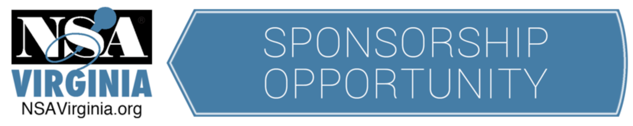

Would you love to have your business or organization known
by the premier organization of professional speakers in Virginia?

National Speakers Association Virginia is an affiliate of the more than 3,100 National Speakers Organization that reaches audiences as speakers, trainers, educators, humorists, motivators, consultants, authors and more.

Sponsor NSA Virginia to expand your reach and success!
Which sponsorship opportunity is right for you? Please contact:
Mary Foley (President) at mary@maryfoley.com

12 Month Premier Sponsor
(2 Year Commitment – 15% Discount)
- Association with NSA Virginia
- Click through logo or graphic ad to sponsor’s website included in NSA Virginia email communications (and additional email communications) for 24 months (approx. 1100 exposures per month)
- Click through logo or graphic ad to sponsor’s website on NSA Virginia website for 24 months
- Opportunity to speak for 2 – 3 minutes at one workshop or online session
- One workshop or online session registration
- Recognition at all workshops and online sessions in President’s opening remarks
- Dedicated posts on NSA Virginia Facebook page with link to sponsor’s website.
Investment: $1,997 (1 Year Commitment $1175)

One-time Workshop or Online Skill Building Session Sponsor
- Available to members & non-members
- Company name & logo featured at workshop or online session
- Opportunity to speak for 2 – 3 minutes at workshop or online session
- Opportunity to display of promotional materials at workshop (available only in-person)
- Click through logo featured on NSA Virginia’s e-mails promoting upcoming workshop or online session
- Click through logo featured on NSA Virginia’s website promoting upcoming workshop or online session
- One registration included
Investment: Members $147 - Non-Members $197

NSA Virginia Sponsorship Form

- Choose your sponsorship type

12-Month Premier Sponsor

Two Year ______ ($1997) One Year _______ ($1175)

One-time Workshop or Online Skill Building Session Sponsor

Preferred Program Date (see nsavirginia.org/events) ________________

Non-Member ______ ($197) Pro Member or Candidate Partner _______ ($147)

- Provide organization information

Company/Organization Information:

Name: _______________________________________________________________________________________________

Company website address to hyperlink logo: ____________________________________________________

Primary Contact Information:

Name: ___________________________________________________________ Title: ____________________________________

Mailing Address: ___________________________________________________________________________________________

Phone: ____________________________________ E-mail: _________________________________________________________

- Sign

Completion of this form by you or your company’s representative serves as a confirmation of your company’s commitment to sponsorship with NSA Virginia. NSA/Virginia is a 501 c(6) entity.

_________________________________________________________ ______________________
Representative’s signature Date

_________________________________________________________
Representative’s name (please print)

- Send form with payment

Form and payment may be submitted by digitally OR by postal mail.

To submit digitally, send PDF of signed form to mary@maryfoley.com. You will be sent a PayPal link to pay by credit or debit card.

To submit by postal mail, send the signed form and check payable to NSA Virginia to:

NSA Virginia
3126 W Cary St #178
Richmond, VA 23221

